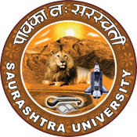

"From Classroom to Boardroom: Harnessing Entrepreneurial Potential in Students"
15th July 2023
At
Class room,
Department of Chemistry,
Rajkot
Contents
Saurashtra University – IIC 2
Event Schedule 2
Event Registration Link 2
Brief about Event 3
Key Points 4
Outcome 4
About the Speaker/Chief Guest 5
Connect Us: 7

Saurashtra University – IIC
The university is dedicated to instruction, research, and extending knowledge to the public (public service). Ministry of Education (MoE), Govt. of India has established ‘MoE’s Innovation Cell (MIC)’ to systematically foster the culture of Innovation among all Higher Education Institutions (HEIs). The primary mandate of MIC is to encourage, inspire and nurture young students by supporting them to work with new ideas and transform them into prototypes while they are informative years. Saurashtra University is one the Organization that have constituted the IIC to foster the vision of MoE and be a part for the promotion and development of innovation ecosystem.

Event Schedule

Event Registration Link

bit.ly/SUSEC-CBHPS

Brief about Event
SU Start-up and Entrepreneurship Council, in collaboration with IIC Saurashtra University, organized a workshop on "From Classroom to Boardroom: Harnessing Entrepreneurial Capabilities in Students" on 15th July, 2023. The event was held at the Incubation Centre, A P J Abdul Kalam Science Laboratory. That was an Excellent opportunity for students interested in entrepreneurship.
Speaker starts session with beautiful though “A good teacher makes you think even when you don’t want to” and gives information on Higer education plays an extremely important role, Higer education significantly contributes towards sustainable livelihoods and economic development of the nation. India moves towards becoming a knowledge economy and society, more and more young Indians are likely to aspire for higher education. as per survey total enrolment in higher education has been estimated to be 40 million with 19 million boys and 21 million girls. The total number of foreign students enrolled in higher education is 46144. Also, sir said knowledge creation and research are critical in growing and sustaining a large and vibrant economy, uplifting society, and continuously inspiring a nation to achieve even greeter hights. Mark Zuckerberg is prime example of a successful individual who transitioned from the classroom to the boardroom. Originally developed as a social networking platform for Harvard student Facebook quickly expanded to other universities and eventually became a global phenomenon Zuckerberg’s vision and determination to connect people through and online platform propelled fakebook’s growth and turned it into one of the world's largest social media networks. It was explained by the speaker.
Then sir talked about start up that startup is a young company founded by one or more entrepreneurs in order to develop a unique product or service and bring it to market. By its nature, the typical startup tends to be a shoestring operation, with initial funding from the founders or their families. Government of Gujrat has developed a student startup and innovation policy, SSIP at state level with a commitment of 100 crore INR grant for student innovators and startups. Sir give example of Infosys founder Narayan Murthy’s journey from a small startup to a globally recognized IT powerhouse highlights his ability to translate his knowledge and vision into a successful business venture. Mark Zuckerberg is prime example of a successful individual who transitioned from the classroom to the boardroom. Originally developed as a social networking platform for Harvard student Facebook quickly expanded to other universities and eventually became a global phenomenon. Mark Zuckerberg’s vision and determination to connect people through and online platform propelled face book’s growth and turned it into one of the world's largest social media networks. It was explained by the speaker.

Investment in science, technology and innovation (STI) is essential for economic development and social progress. After that sir providing information regarding ultra violate lights, visible lights and how to use ultra sonic sound is very useful in our day-to-day life. Here are some illustrations of this technology.
1. Ultraviolet lamp: Ultraviolet lamp is one that emits mostly ultraviolet light. These germicidal lamps are often used to kill microbes(germs).
2. Ultraviolet Light: wavelengths range from 400nm to 10nm; the frequency is high enough with UV rays to penetrate living cells and cause them damage.
3.UV-C air disinfection: when emitted at certain wavelengths and for specific amounts of time, UVC light can damage the genetic material — DNA or RNA — in bacteria and viruses, inhibiting their ability to replicate and, in turn, causing their normal cellular functions to break down, explains Chris Olson, microbiologist and program.
4.Fruits and Vegetables: treating pre-packed fruits and vegetables, reduces spoilage and eliminates insects.

Key Points
During the session, below mentioned points were discussed:
- Social networking platform for Harvard students
- Entrepreneurial potential self-assessment
- Knowledge and vision into a successful business venture
- Economic development of the nation
- Responsibility is the price of greatness
- FAQs related to Harnessing Entrepreneurial Potential in Students

Outcome
According to the event, students learned that being an entrepreneur requires them to take on significant responsibility and that comes with significant challenges and potential rewards. Entrepreneurship is a mindset, an attitude that takes a certain approach to doing things.
Also, if you want to be a successful entrepreneur, one should cultivate entrepreneurial qualities in oneself. The requirements of entrepreneurship like integrity and reliability, punctuality, perceptiveness, ability to learn from mistakes, ethical consciousness, foresight was explained by the speaker with examples.

About the Speaker/Chief Guest
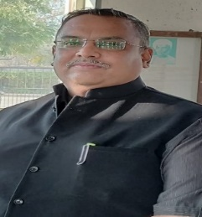

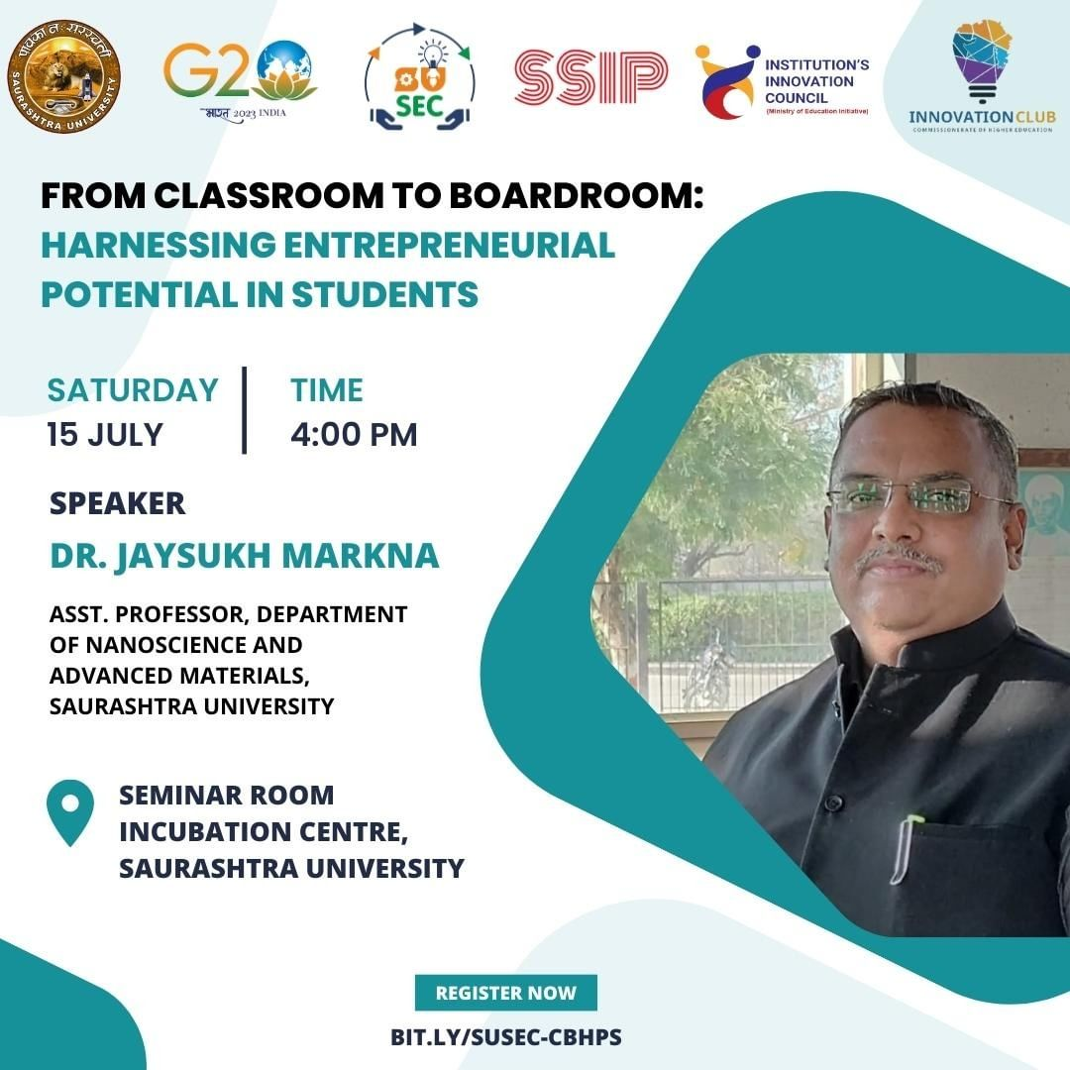

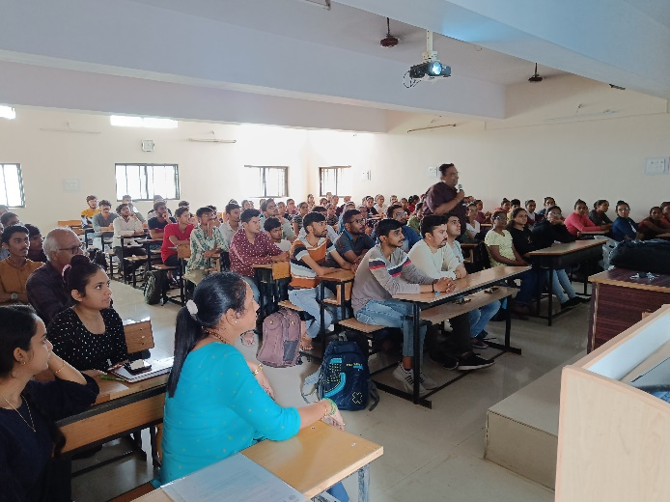
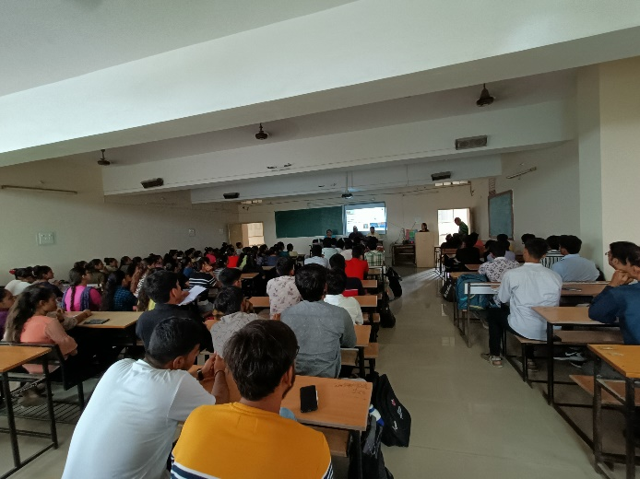
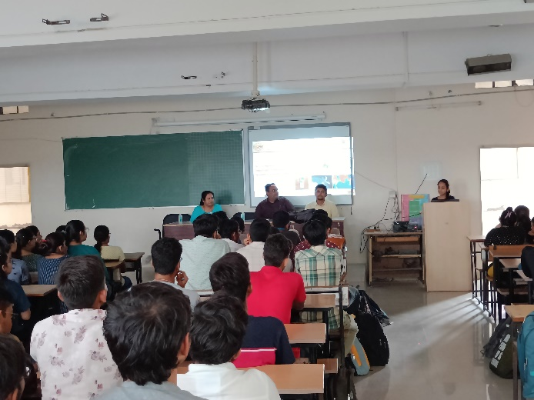
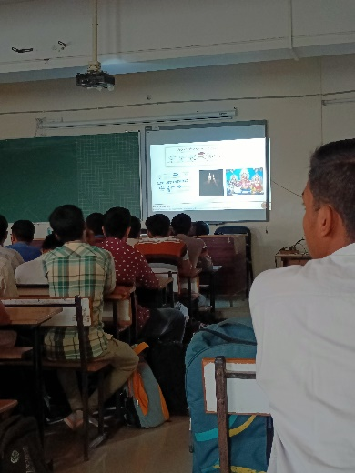
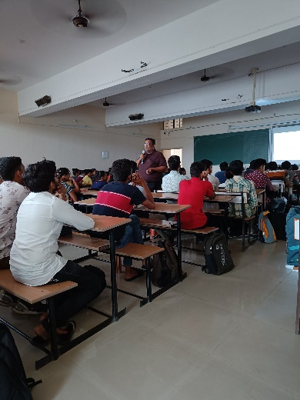
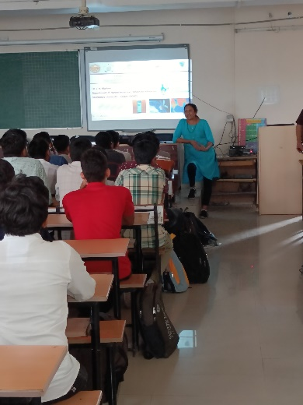

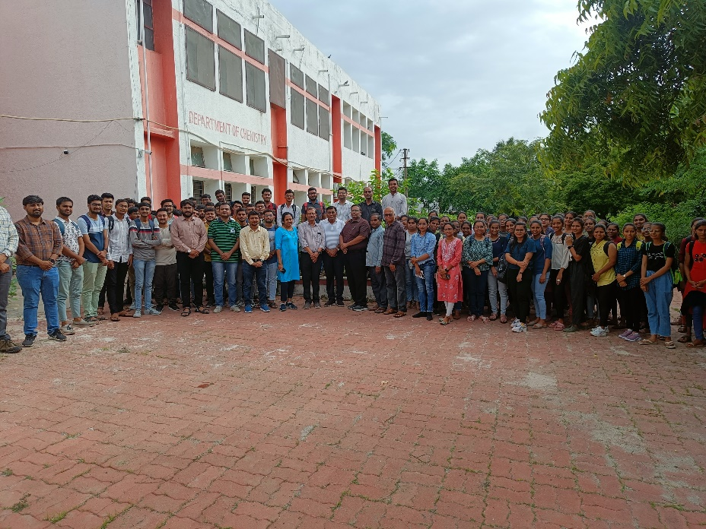

Connect Us:

https://www.linkedin.com/company/susec iic@sauuni.ac.in
https://www.facebook.com/iicsauuni https://bit.ly/SUSECLocation
https://www.instagram.com/susecrajkot https://bit.ly/SUSEC-youtube

